Project Design Phase Problem – Solution Fit Template

Date | 02 November 2025
Team ID | NM2025TMID00263
Project Name | Laptop Request Catalog Item
Maximum Marks | 2 Marks

Problem – Solution Fit Template:
The Problem–Solution Fit defines how effectively the Laptop Request Catalog Item (ServiceNow) addresses the real challenges faced by employees and IT administrators. It ensures that the developed solution directly solves the identified pain points of manual request handling, approval delays, and lack of visibility in hardware management.

Purpose
- Solve Real Employee Challenges
Streamlines the manual and time-consuming laptop request process by introducing an automated ServiceNow catalog item.
- Enhance Efficiency and Adoption
Reduces delays and confusion by applying dynamic form behaviors (UI Policies and UI Actions) that guide employees through accurate data entry.
- Improve Communication and Transparency
Sends automated notifications to employees and IT teams, ensuring clear updates on approval and fulfillment status.
- Increase Workflow Accuracy and Trust
Ensures all requests are validated, tracked, and approved through ServiceNow workflows — improving confidence in the IT request process.
- Understand and Improve Existing Systems
Replaces fragmented manual requests with a structured, cloud-based workflow that supports scalability and continuous improvement.

Template:

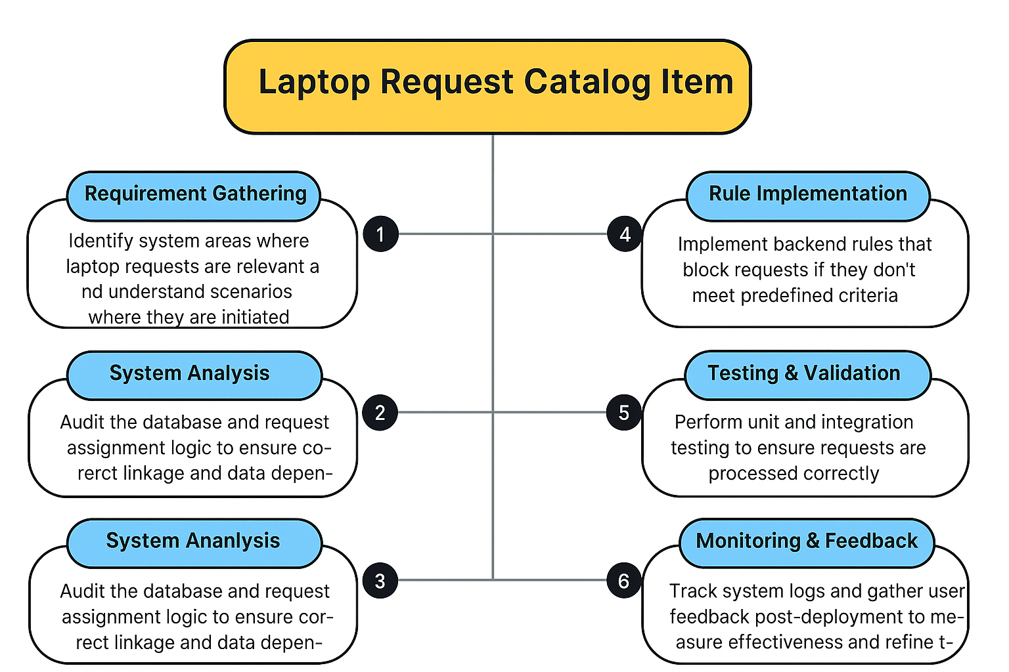

The project “Laptop Request Catalog Item” focuses on automating and simplifying the process of requesting laptops within an organization using ServiceNow. Traditionally, employees relied on manual or email-based requests, leading to delays, incomplete data entry, and inefficient tracking.
To resolve these challenges, the project introduces a Service Catalog item that allows users to submit structured laptop requests through a dynamic form. The catalog form includes interactive fields such as Laptop Model, Justification, and Additional Accessories, with smart behaviors controlled by Catalog UI Policies and UI Actions (like a reset button).

This implementation ensures accurate data collection, improved user experience, and better governance. It also supports update set migration for deployment across multiple ServiceNow instances. Overall, the solution enhances operational efficiency, transparency, and automation in IT asset management.

